CSCI 491 – Project 4 – Spatial Regression
Milestone Process Documentation

Vectorizing polygons as lines to get borders
QGIS Preprocessing
National country borders
- Download adm0 country polygons
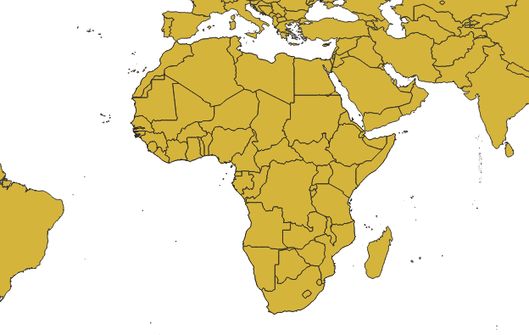
- Save selected features with CONTINENT=Africa, and delete countries that are entirely islands (Cabo Verde, Comoros, Madagascar, Sao Tome & Principe)
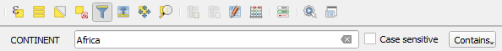
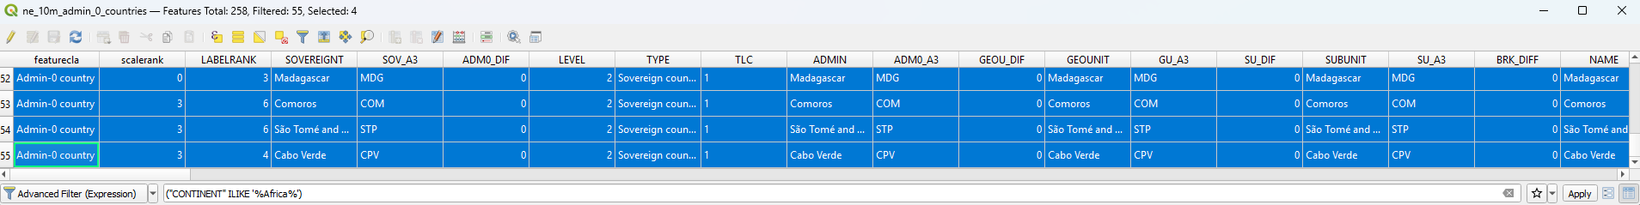
- Split multipolygon countries into individual pieces
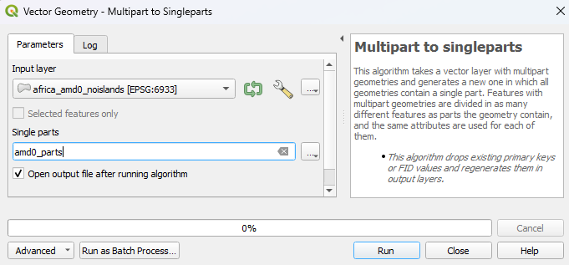
- Fix geometries using Linework as the repair method for polygons
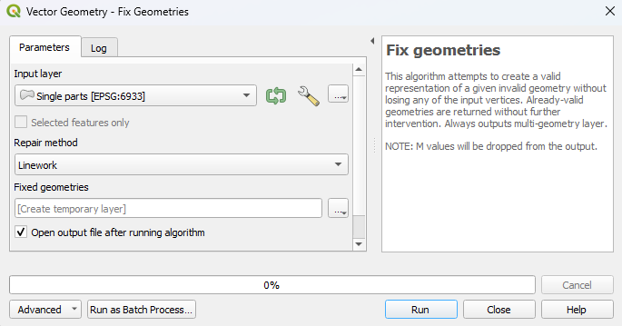
- Remove countries’ territorial islands by identifying polygons that don’t touch any other polygon
  - Create new field to indicate if it touches another polygon (1) or if it’s isolated (0). Set default value to zero for all rows.
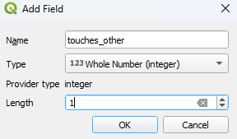
  - In Processing toolbox, use Select By Location to find polygons touching another, and filter for only those bordering another country polygon. This will differentiate between islands and exclaves.
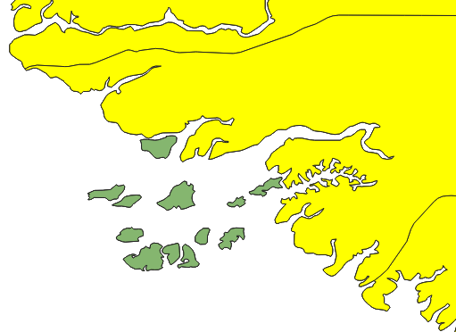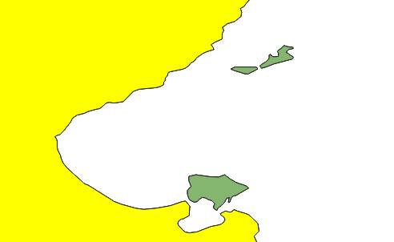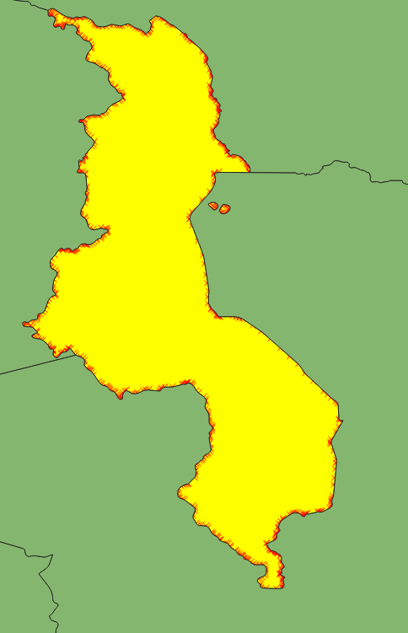

  - In Field Calculator, update existing field touches_other with “1” for these selected features (55 polygons, with one extra polygon for disputed Bir Tawil triangle). Islands will keep default value of 0.
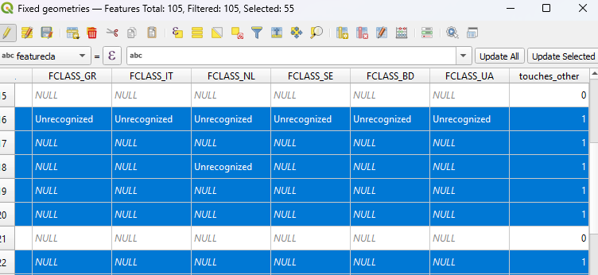
  - Drop rows where touches_other = 0.
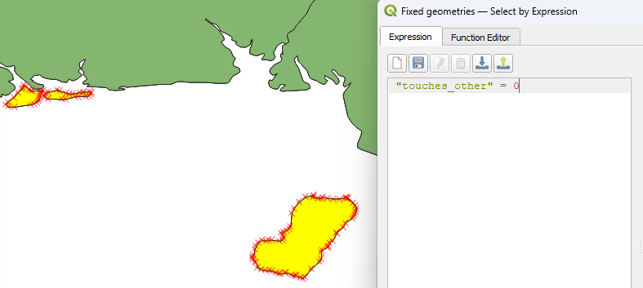
- Reproject EPSG:4326 to EPSG:102023 (Africa Equidistant Conic) to put data in meter-based CRS to fill holes/gaps using square meters as threshold
- Fix gaps (only gap was between countries was Sudan and Bir Talwi triangle; Egypt had a few small holes due to same disputed zone in SE)
  - Gaps were measured at around 275m, so can use snap geometries tool with 300m tolerance.
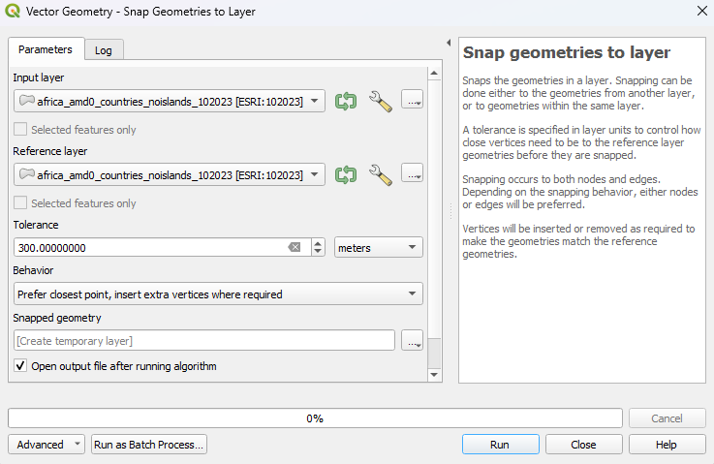
  - For gaps within Egypt, select only Egypt polygon and use Delete Holes toolbox.
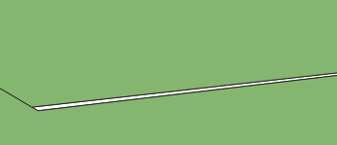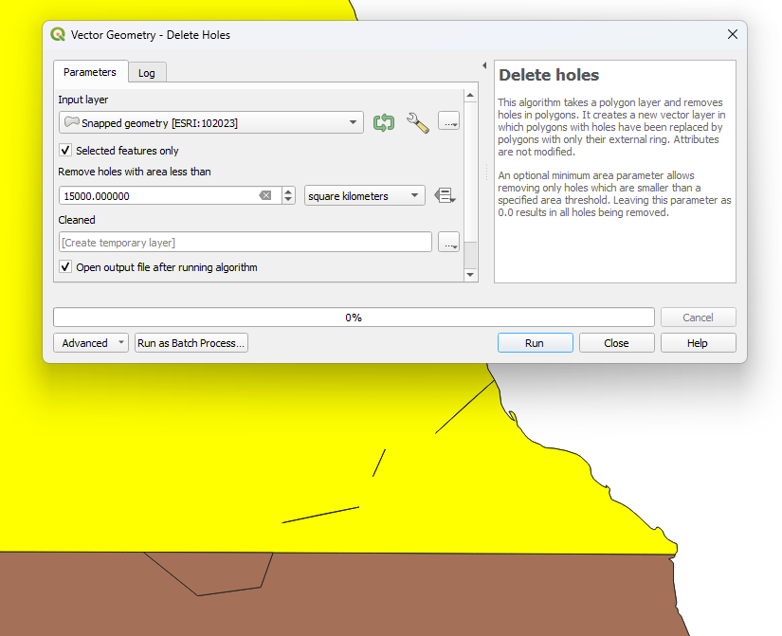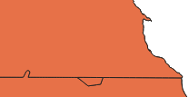
- to extract line features from polygon edges.
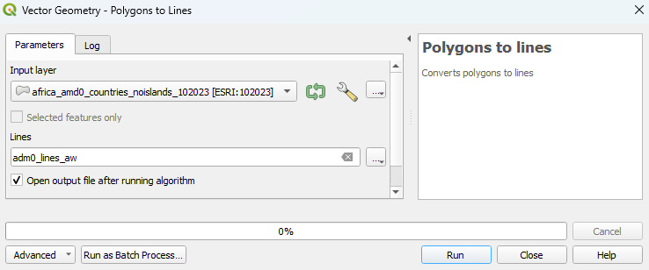
- Explode lines to get individual border segments
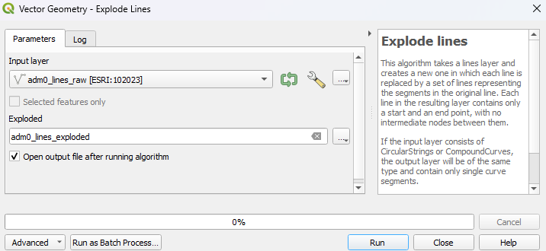
- Remove duplicate border lines overlapping on top of each other.
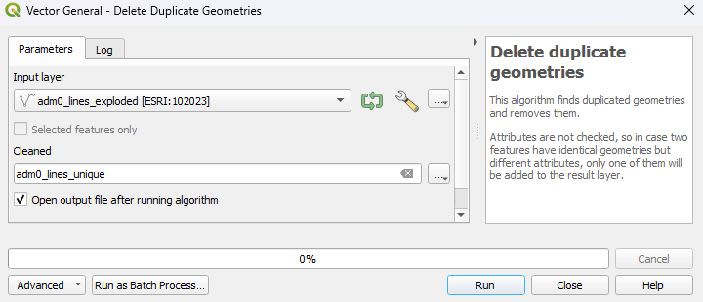
- Save attributes of bordering country names that share border line.
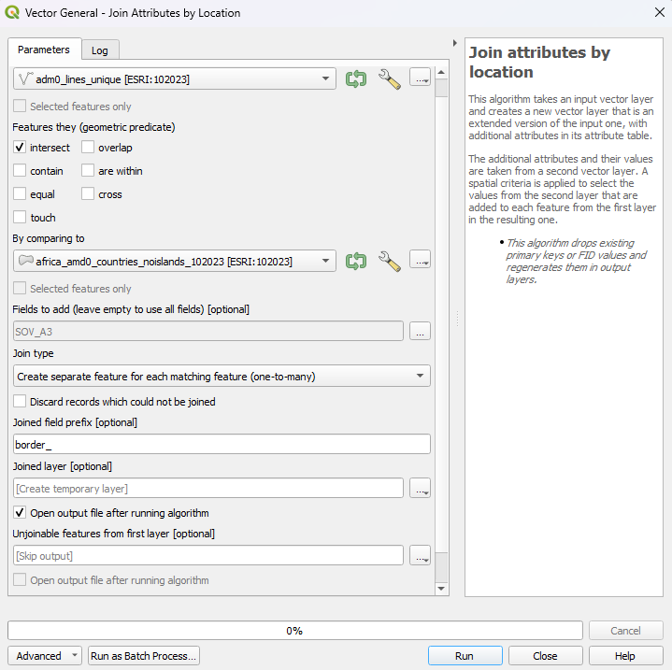
- Save concatenated border name, and number of countries along the border line. Coutry counts of only 1 are coasts and can be removed from the border dataset.
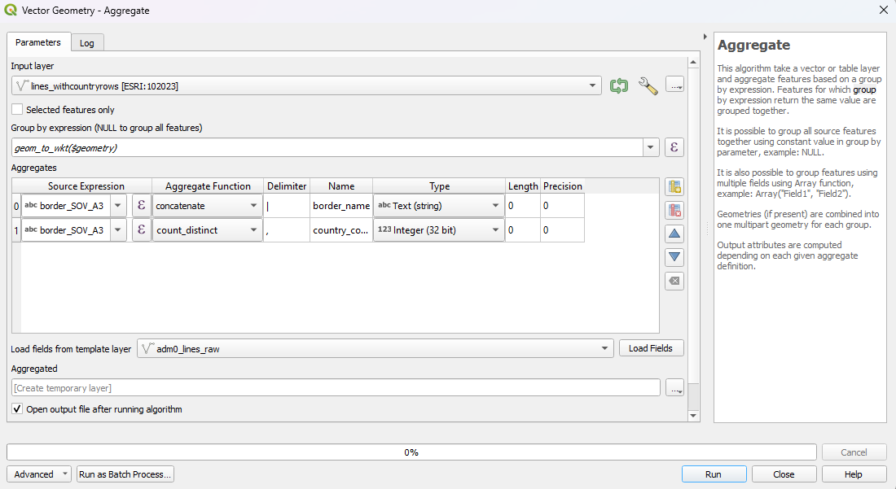
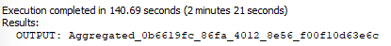
- Extract lines that have 2 or more countries bordering it (to not include coasts as part of border dataset)
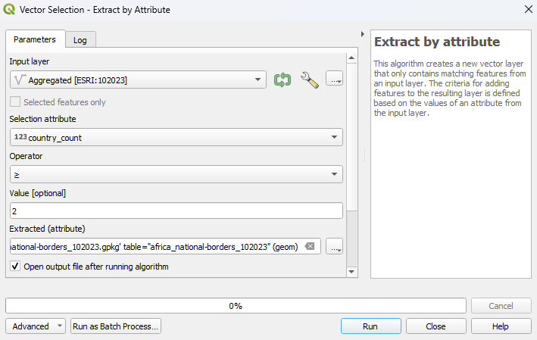
- Manually delete any weird coastal areas near border intersectioncs with coast that got counted wrongly
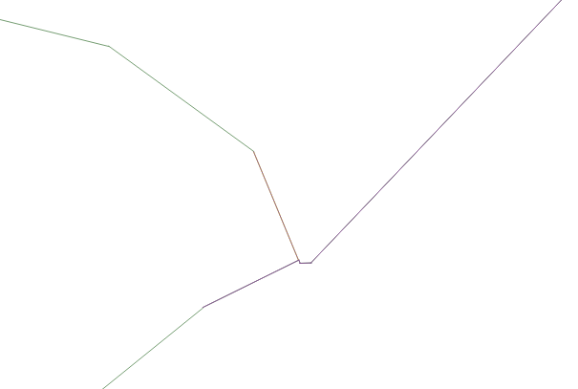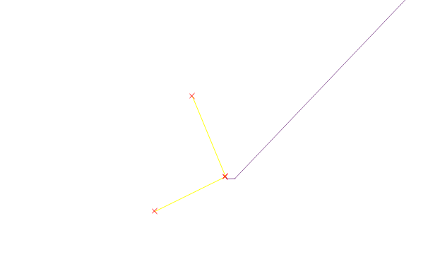

- Save file as geopackage with CRS set to 102023
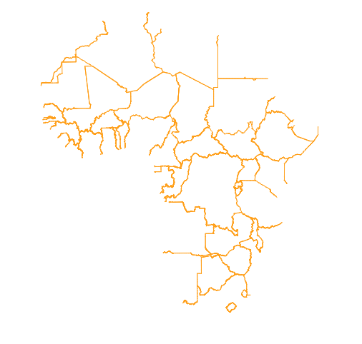

Create equal-area grid cells of Africa for units of analysis

Create equal-area grid of 10km squared
- Reproject layer to Africa equal-area conic CRS (ESRI:102022)
- Dissolve African continent (no islands) into single polygon
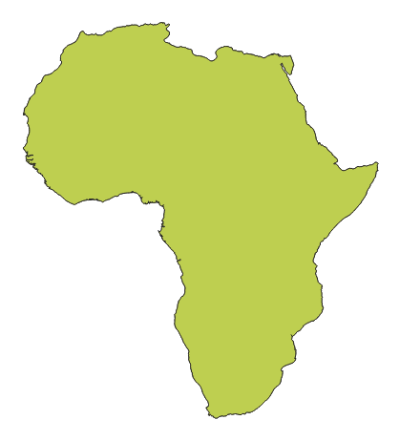
- Use Grid toolbox to create multiple grid resolutions. Set horizontal/vertical spacing to cell size (10/25/50/100 in km), use Africa mainland as extent.
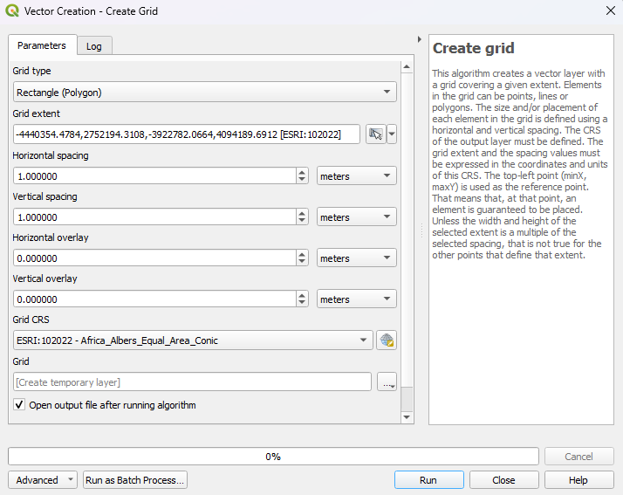
  - 10km cell size
  - 25km cell size
  - 50km cell size
  - 100km cell size
- Clip grid to Africa polygon, to remove ocean cells
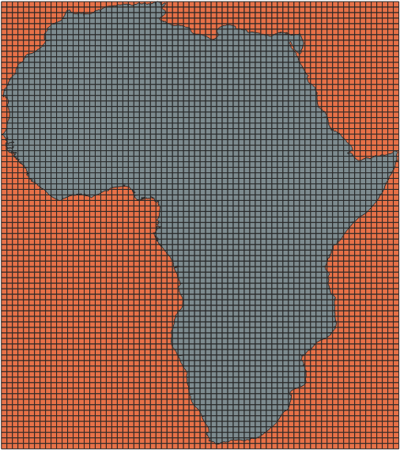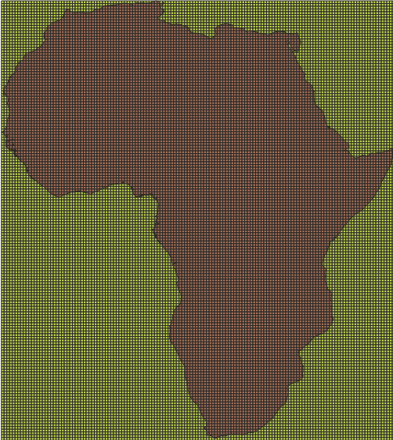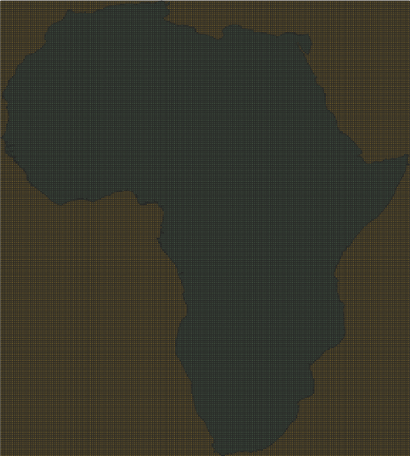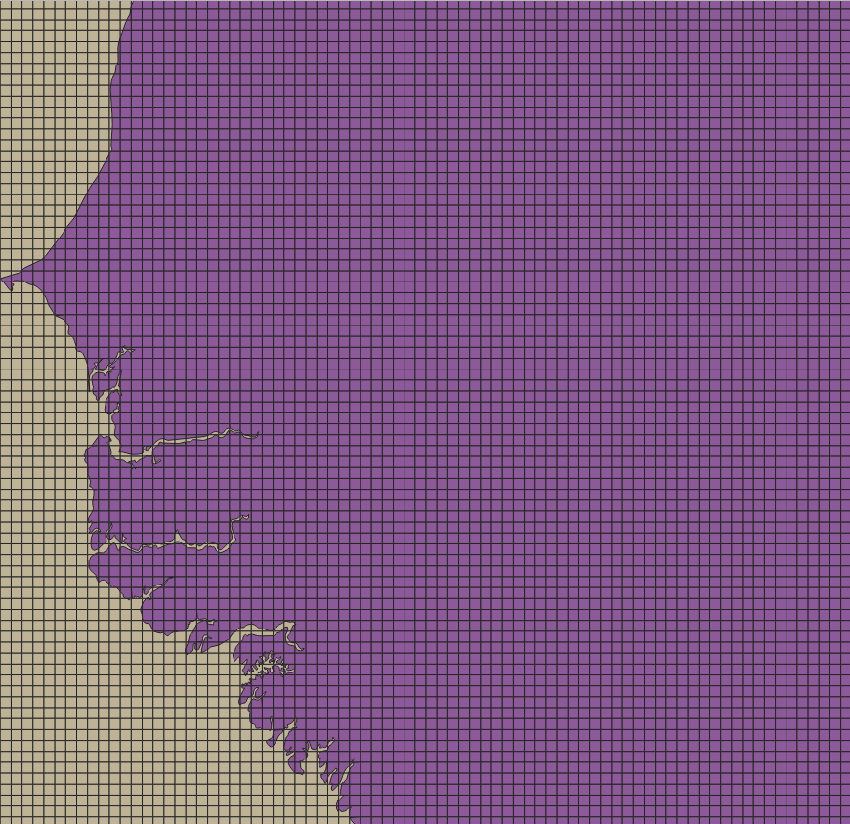
- Identify coastal grid cells

ACLED Conflict data
- Clip ACLED data to Africa mainland

Controls Data
Population
- Clip population density raster to Africa mainland

Roads
- Clip roads data to Africa mainland

Rivers
- Clip roads data to Africa mainland

Land Cover
- Clip roads data to Africa mainland

